Chapter 6
''So? Oh sorry, do you even speak English? Italian, maybe? Bisogno di aiuto?''
''I prefer English, thank you.'' Gilbert said. Ruby laughed and opened the door eider.
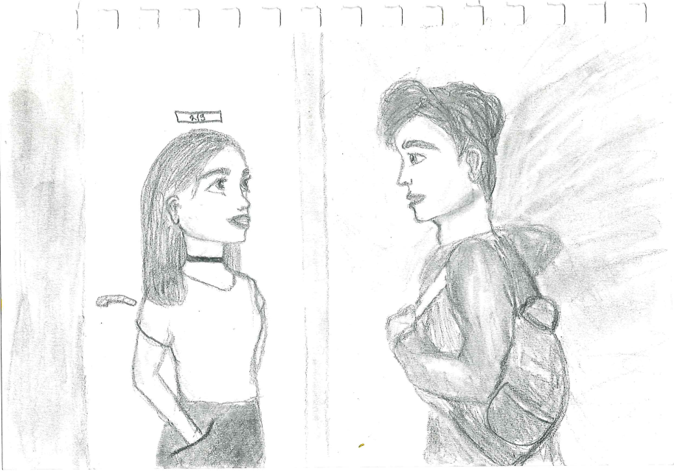
''Come in, people.'' She said and bowed. We came inside and Ruby closed the door. Her hotel room looked so girly. Pink dresses on her bed, some glossy lipsticks on the floor, a few books on the pink desk.
''So, I guess you are Diana's friends.'' She said and took one of her dresses from the bed. Gilbert looked at me, then looked at Ruby and sighed.
''Yes, we are her friends and she said that you can help us with something.'' I said because Gilbert just couldn't. And I don't know why. Ruby opened her big closet and rolled her eyes.
''Please give me my chair. It's right there.'' Ruby said and pointed at a chair. I got up and gave it to her.
''I hate being so short, ummm... thank you.''
''Anne.'' I smiled, Ruby started talking about how she loves being here, because this is her ''second home''. She also said that her mother was the owner of this hotel, but then her dad took her place, Diana's dad is their friend and then I stopped listening.
''So, can you help us? We need one key.'' Gilbert finally started speaking. Ruby turned and said: ''Sure, what is your room number?''
''Oh, well, I don't think you got it. We don't need that key.'' Gilbert said while Ruby was giving me the exact same key that we have. Ruby looked at Gilbert and smiled. That moment, Ruby got out of her room and ran as fast as she could to my room. We were following her. She unlocked my hotel room and quickly moved the big carpet. Gilbert gasped. How did she know? Ruby didn't even say anything. She just looked creepy. Her eyes were so big, like a kid looking at candy.
''You know what is inside?'' I asked her. She got up and started explaining.
''Nobody knows, I guess, I know where the key is, I found this door like, three years ago when I was looking for my lipgloss. Nobody was in this room so I got in and I never found the lipgloss, but I found this door.'' She said.
''You know where the key is and yet you never dared to open the door?'' Gilbert asked. Ruby sighed: ''I was so scared, but now you two are here, so we can open them.'' Ruby moved the carpet so that we can see the door. Ruby smiled and said: ''I am finally doing this.''
''You? We are doing this, not just you!'' Gilbert said.
''Gilbert, can you please be quiet?'' I said and he rolled his eyes again. I feel like he can only do that.
''I have the key, so let's just do this.'' Ruby said and took a little key from her pocket.
''Be faster, we are waiting like, two hours for this.'' Gilbert started to complain.
''I am waiting three years, so shut up.'' Ruby said and sighed. She turned the key three times, first to the right, and then to the left. She kept doing that until we heard the sound: click.

