Chapter 3
''Miss, then why were you screaming?''
''What? Well that's a stupid question. There was a boy admiring the hotel, and he was walking around the hotel like he was never here before. And I was taking a selfie when he bumped into me! And he broke my phone!''
''Okay Miss, you scared some people, maybe you didn't have to scream so loud.'' the hotel owner said. That girl was lucky the hotel owner was kind to her. I mean, I wouldn't be kind at all. So what happened? Gilbert was just being Gilbert, he crushed into a girl named Diana. Diana was also being Diana. So an accident happened. Gilbert apologised but Diana didn't accept his apology. And I don't think she will.
''Okay Anne, I got it, you got scared.'' Gilbert said while we were drinking tea in my room.
''Well, she sure is not a good singer.'' I said. He laughed. Then someone knocked on the door. At first, I thought it was room service. But then, we saw Diana. She was standing in front of my door. How did she find out where my room is? And what did she want? It was so strange.
''Ummm, hi, I don't think we met, I'm Diana.'' she said. It was so weird. Her act has changed. I welcomed her, she entered my room. I asked her if she wants tea. And so we were sitting on my room's balcony and drinking tea. Just the three of us.
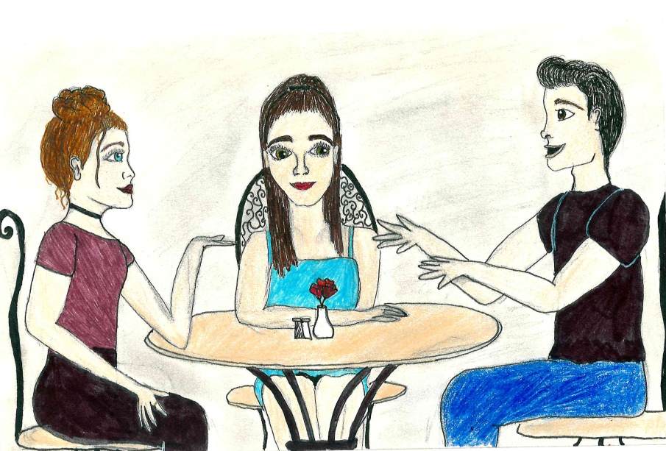
''I'm sorry I yelled at you Gilbert, I was just so mad!'' she said and looked at Gilbert. He was confused, I could see. Why would Diana yell at Gilbert and then come to MY room and apologise.
''So Annie, right?''
''I'm Anne, spell it with an e.'' I responded. Gosh, I don't know how many times I said that in my life. People calling me Annie, Anna, Ann... Yeah, spells with an e, learn it people.
''Sure, sorry for yelling again.'' Diana said and sighed.
''Sorry I broke your phone...'' Gilbert said. Since I only knew Gilbert here and I don't want him to be my only friend, I asked Diana to join us at lunch. We will be going to a restaurant and then we will go and take some photos. And maybe even visit some museums.
''Sure, see you at 7 then.'' Diana said and closed the door. Gilbert rolled his eyes as soon as Diana left.
''What now?'' I asked him. He didn't look happy.
''She seems kind of boring.'' he said. I somehow knew he was going to say that. When Diana was talking, he was just rolling his eyes and playing games on his phone.
''Come on Gilbert, you can't hang out with me all the time. It's good to have many friends.'' I told him. And I know I was right. ''Fine.'' Gilbert sighed.
At 7 we all went to a restaurant. Diana was wearing a blue dress and golden earrings. She really looked pretty. We were walking and Diana and Gilbert started talking. I just took my phone out and took some photos of Atlanta. The sunset was so beautiful. A mix of orange, purple and pink. The restaurant's name was: Ray's In The City. It was a weird name. But Diana knew the city better than us, so we went there. Diana's dad lived in Atlanta so she was here more than ten times. ''But then he got engaged and moved to New York.'' Diana explained while we were waiting for our food.
''I can tell you a lot about myself, so listen.'' She said and winked. Gilbert rolled his eyes again. This is going to be a long night.

