Chapter 2
''Do you see that?'' he asked me.
''That?'' I asked and pointed to the map.
''Yes, that's called Atlanta. I was there three times. Anne, it was beautiful!''
''Can I go there?'' I asked. He was confused with that question, that's for sure. His answer confused me. I didn't understand it. Maybe? What was that supposed to mean??
''Why maybe?'' I asked him and closed the map.
''You are only three, you are too young to go somewhere out of the country, and I don't think your mother would be happy if you went there...''
Dad was always letting me do things that my mother would never allow. So why is he like this now? Why is he on her side now? I left the room.
''Oh come on Anne! I'm sorry!'' I heard him saying as I was leaving. Then why did he even show me something that he knew I would love?
''But mommy he won't let me! How is that okay?'' I was screaming and crying in my mother's arms. She sighed. I know, I know, when I was a kid I was really spoiled. I would cry if something wasn't going the way I planned. What a brat.
''Thomas, can we talk?'' I remember my mother saying and looking at my dad like she was gonna kill him. Then they went to the living room. I didn't hear much. So I came closer to the door.
'' What was this all about? Mind explaining?'' my mom said. She was really angry and I didn't know why.
''Marilla, I just tried...'' he couldn't even finish the sentence.
''Just tried what? Get her killed at Sheraton?'' mom said. I didn't understand anything.
''Hey, stop now! You know I would never.'' he said but mom was so angry.
''I don't want to spend my nights in a hospital again, Thomas! Remember in how much pain you were? And the police are still trying to find them! You are insane to even tell her that you were there! She is three!'' My mom was still yelling. After their ''talk'', oh I mean my mom's talk, they came back and looked at me like nothing happened.
''We have a deal.'' my dad said and came towards me. He explained everything. Well, almost everything. He promised that when I turn 16, I will go to Atlanta. Alone. That was still a shock for me because I didn't even know maths so I thought it will be in like 1000 years. My mom also agreed. Which was weird. She never agreed with anything my dad asked her. Except to marry him. So ''my 1000 years'' flew away very fast. And here I am, sitting on a plane and talking with you, dirty handed stranger. Gilbert laughed.
''Fun story! So, Anne with an e, do you think we are landing soon?'' he asked.
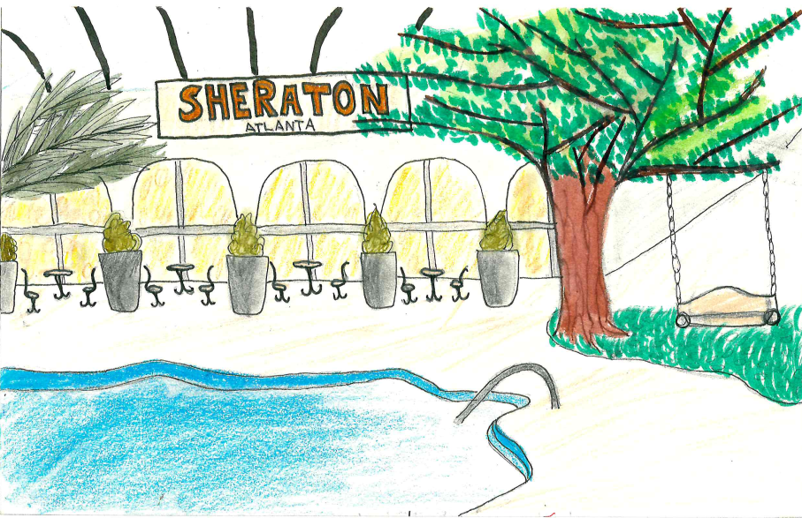
''How am I supposed to know? It feels like we have been flying forever.'' I said. Gilbert laughed, again. We finally landed thirty minutes later. The plane was half empty so we didn't have any problems leaving the plane. The wind in Atlanta was crazy! I felt like it was summer. It was also nice weather. The airport was so cool. I started shaking because I never thought I would be here, alone. The hotel's name is Sheraton and that is the location I have to be. Then I have to call my mom. She must be worried. The hotel is just so amazing. I was in room 333, and Gilbert was in room number 331. I was unpacking when I heard a loud scream. I opened the door, it was kinda scary to even find out who screamed.

