Chapter 1
6 a.m. Is that too early for you? It is for me. Have you ever wanted to go somewhere? But, you couldn't? I always wanted to go to Atlanta. You know where that is? In Georgia, USA. Many people told me that there is nothing special. I doubt it. It sure is special. Fox Theatre, Atlanta History Center, Atlanta United match, Krog Tunnel, Criminal Records, Stone Mountain and many, many, many more.My father told me that he used to live there.. Since then, I had my goal. He showed me every photo he took in Atlanta. It was amazing!
Today is finally the day. I turned 16 three days ago. My mom promised me that I will go to Atlanta when I turn 16. She promised, so there are no doubts. 6 a.m. I woke up at 6 a.m. It was a really strange feeling. Really strange. Did coffee help me? Nope. It didn't. Even my dog was sleeping.
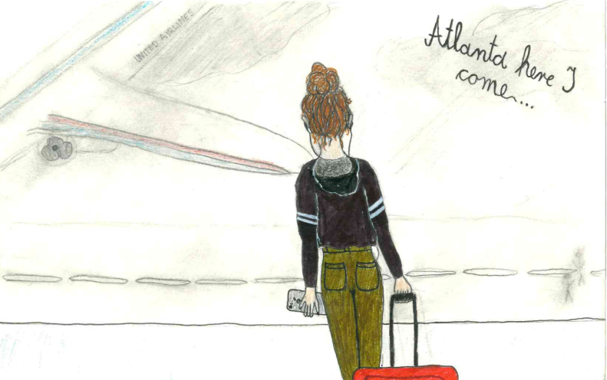
''Anne, where is your brown coat?!'' my mom was yelling from her bedroom.
''I am wearing it, you know?''
''Don't answer me, young lady, or you can just say bye to Atlanta!'' she replied coldly.
What should I say to that? Nothing, I should just roll my eyes. And that's exactly what I did.
''I know you just did your ''eye roll'' young lady!'' she said. I exhaled.
''Did you just exhale?''
''No, I am fine mom, I am not sick trust me.'' I said just to finish our ''little talk''.
An hour later we were at the airport. My mom was looking at her phone all the time. She also inhaled and exhaled a lot. I could see that she was really impatient,
''Mom, you can go to work, seriously.'' I tried to calm her. Also, I didn't want her to be late for work. Her boss can really lose temper easily. She looked at me and smiled.
''Really?'' she asked me. I nodded. She smiled again. I was alone at the airport for 15 minutes. My bag was really heavy and I was really impatient. I just wanted to be in Atlanta. Now.
I reached for my phone in my pocket when it fell on the floor. Seriously? I put my bag down when I saw a hand taking my phone. I looked up. There was a boy with black hair, brown eyes and he was holding a ticket for Atlanta. And my phone. He coughed. I took my phone from his hands.
''Thank you, it wasn't really necessary.'' Was I too cold? Yeah.
''No problem.'' He replied and smiled. How kind? It wasn't really. Who knows how many bacteria he has on his hands. Kinda gross. I took my jacket and gently peeled off my phone screen. I looked up and I saw that my plane has just arrived. Finally.
Why are planes so small? Another big question asked by Anne Shirley. There are so many people and the plane is just so small. The bottom and the top of the plane make me feel really claustrophobic.
''Where is my seat?'' I asked myself. 33. My plane seat was just next to the window. Yes, by the window. And yes, I am sitting next to the boy with a lot of bacteria. Seriously. How am I supposed to sit next to someone who touched my phone and has a lot of bacteria? Before I sat down, I took a napkin from my bag and yes, I sat on it. Who knows how many people sat on that seat? Another great question. Plenty. Every day someone sits on that chair and it must be really dirty. What's even his name? Bacteria boy?
''Gilbert Blythe.'' he said.
''I beg your pardon?''
''That's my name. I know you want to know my name.'' he said.
I looked at him. Did he really just do that?
Gosh, this is really going to be a long flight.
''You know what else is amazing?'' Gilbert asked me 3 hours after we met. He was so talkative.
''No.'' I sighed.
''I have never even been on a plane before! And now I am looking at the clouds! Do you know what they are made of?'' He asked me.
I looked at him. I was so tired. Am I really becoming friends with the boy who has a lot of bacteria and his dirty hands? Are you even wondering why am I so careful? With all the sickness and other awful things?
When I was 8, my mom took me to her friend's lab. It was really cool. I had a chance to look through the microscope. And that's when my life become weird. Since then I always wash my hands after I shake hands with someone. I know, weird, right?
''Anne?'' Gilbert asked me when he noticed that I zoomed out for a few moments.
''Spell it with an e.'' I said.
''What?'' he looked at me.
''My name. Anne. Spell it with an e.''
He is not the first person to call me Anne without spelling it with an e. Every person used to call me like that, so I guess I can't blame him. 15 minutes later we arrived to Atlanta. Finally. Things will be so much better now. At least that's how I thought. Oh, how wrong I was.

